# Consider the following schema for Order Database:

**SALESMAN (Salesman_id, Name, City, Commission)**

**CUSTOMER (Customer_id, Cust_Name, City, Grade, Salesman_id) ORDERS (Ord_No, Purchase_Amt, Ord_Date, Customer_id, Salesman_id)**

**Write SQL queries to**

1.  **average.**
2. **Find the name and numbers of all salesmen who had more than one customer.**
3. **their**

**cities (Use UNION operation.)**

1. **Create a view that finds the salesman who has the customer with the highest order of a day.**
2. **Demonstrate the DELETE operation by removing salesman with id 1000. All his orders must also be deleted.**

**Solution:**

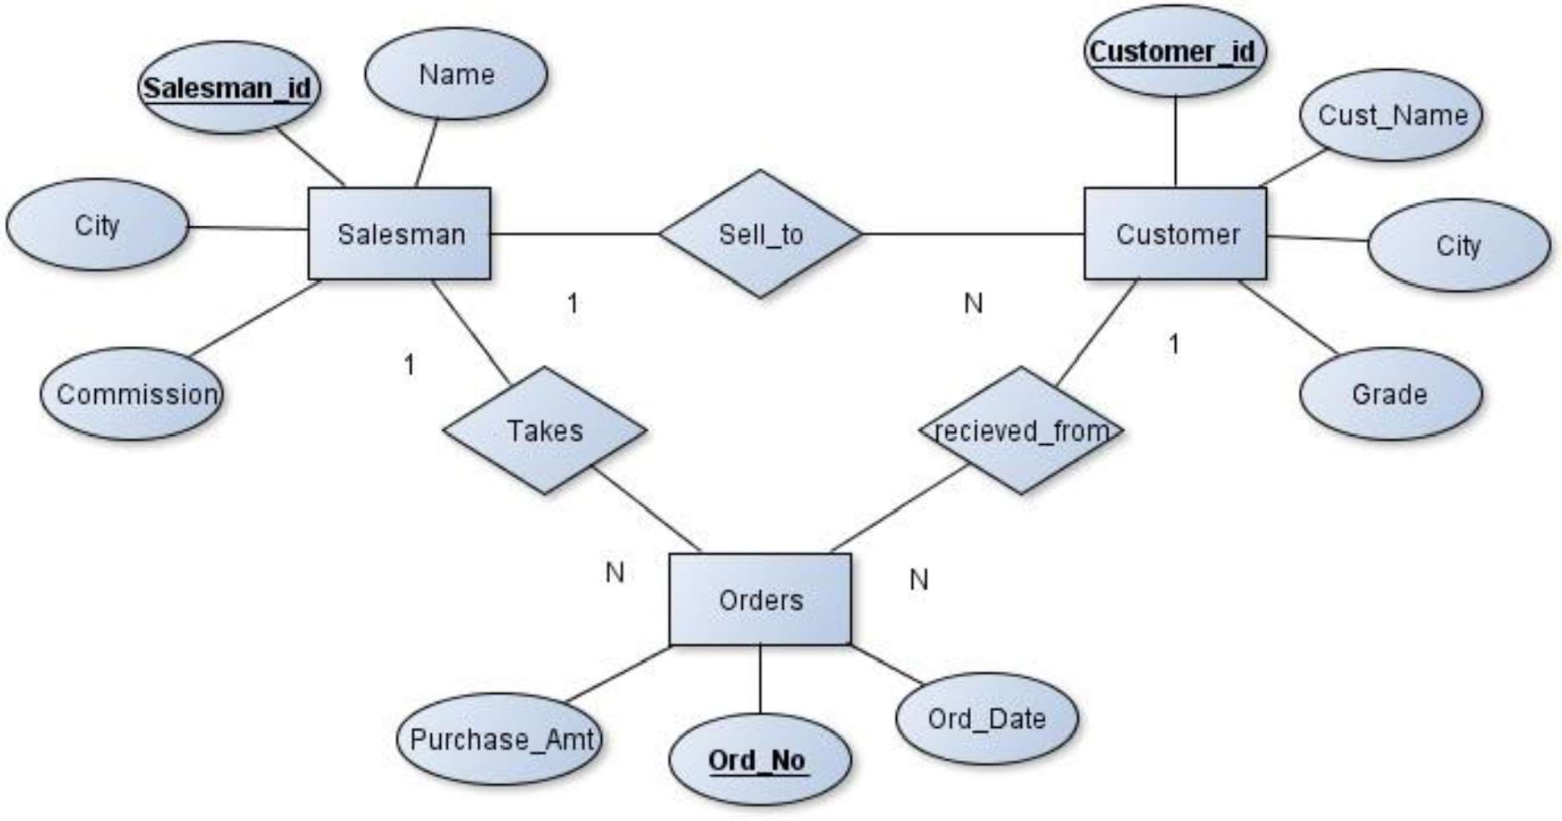**Entity-Relationship Diagram**

**Schema Diagram**

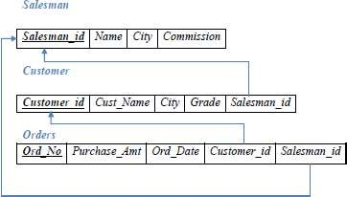

**Table Creation**

CREATE TABLE SALESMAN ( SALESMAN_ID INT (4) PRIMARY KEY, NAME VARCHAR (20),

CITY VARCHAR (20),

COMMISSION VARCHAR (20));

CREATE TABLE CUSTOMER ( CUSTOMER_ID INT (5) PRIMARY KEY, CUST_NAME VARCHAR (20),

CITY VARCHAR (20), GRADE INT (4),

SALESMAN_ID INT (6),

FOREIGN KEY (SALESMAN_ID) REFERENCES SALESMAN (SALESMAN_ID) ON DELETE SET NULL);

CREATE TABLE ORDERS ( ORD_NO INT (5) PRIMARY KEY, PURCHASE_AMT DECIMAL (10, 2), ORD_DATE DATE,

CUSTOMER_ID INT (4),

SALESMAN_ID INT (4),

FOREIGN KEY (CUSTOMER_ID) REFERENCES CUSTOMER (CUSTOMER_ID) ON DELETE CASCADE,

FOREIGN KEY (SALESMAN_ID) REFERENCES SALESMAN (SALESMAN_ID) ON DELETE CASCADE);

#### Table Descriptions

DESC SALESMAN;

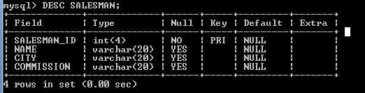

DESC CUSTOMER;

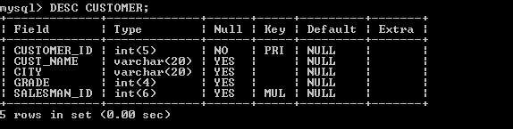

DESC ORDERS;

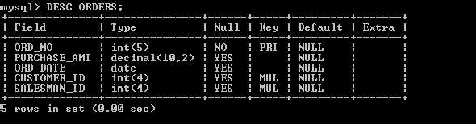

Insertion of Value

INSERT INTO SALESMAN VALUES(101,'RICHARD','LOS ANGELES','18%'); INSERT INTO SALESMAN VALUES(103,'GEORGE','NEWYORK','32%'); INSERT INTO SALESMAN VALUES(110,'CHARLES','BANGALORE','54%'); INSERT INTO SALESMAN VALUES(122,'ROWLING','PHILADELPHIA','46%'); INSERT INTO SALESMAN VALUES(126,'KURT','CHICAGO','52%');

INSERT INTO SALESMAN VALUES(132,'EDWIN','PHOENIX','41%');

INSERT INTO CUSTOMER VALUES(501,'SMITH','LOS ANGELES',10,103); INSERT INTO CUSTOMER VALUES(510,'BROWN','ATLANTA',14,122); INSERT INTO CUSTOMER VALUES(522,'LEWIS','BANGALORE',10,132); INSERT INTO CUSTOMER VALUES(534,'PHILIPS','BOSTON',17,103); INSERT INTO CUSTOMER VALUES(543,'EDWARD','BANGALORE',14,110); INSERT INTO CUSTOMER VALUES(550,'PARKER','ATLANTA',19,126);

INSERT INTO ORDERS VALUES(1,1000, '2017-05-04',501,103); INSERT INTO ORDERS VALUES(2,4000,'2017-01- ,522,132); INSERT INTO ORDERS VALUES(3,2500, '2017-02-24',550,126); INSERT INTO ORDERS VALUES(5,6000,'2017-04-13',522,103); INSERT INTO ORDERS VALUES(6,7000, '2017-03-09',550,126); INSERT INTO ORDERS VALUES (7,3400,'2017-01-20',501,122);

SELECT * FROM SALESMAN;

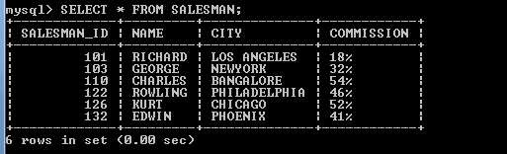

SELECT * FROM CUSTOMER;

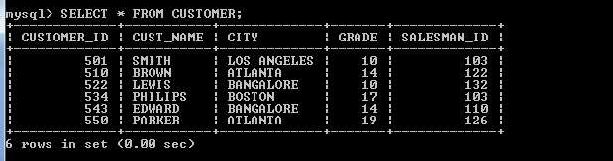

SELECT * FROM ORDERS;

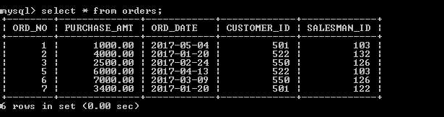

#### Queries

1.  **average.**

SELECT GRADE, COUNT (CUSTOMER_ID) FROM CUSTOMER GROUP BY GRADE

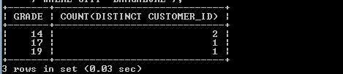HAVING GRADE > (SELECT AVG (GRADE) FROM CUSTOMER WHERE CITY='BANGALORE');

SELECT GRADE,COUNT(DISTINCT CUSTOMER_ID) FROM CUSTOMER GROUP BY GRADE

HAVING GRADE >(SELECT AVG(GRADE) FROM CUSTOMER WHERE CITY='BANGALORE');

#### Find the name and numbers of all salesmen who had more than one customer.

SELECT SALESMAN_ID,NAME FROM SALESMAN A

WHERE 1 <(SELECT COUNT(*) FROM CUSTOMER WHERE SALESMAN_ID=A.SALESMAN_ID)

### OR

SELECT S.SALESMAN_ID,NAME, FROM CUSTOMER C,SALESMAN S WHERE S.SALESMAN_ID=C.SALESMAN_ID GROUP BY C.SALESMAN_ID HAVING COUNT(*)>1

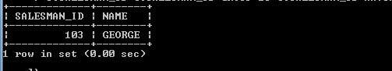

#### their cities

**(Use UNION operation.)**

SELECT S.SALESMAN_ID,NAME,CUST_NAME,COMMISSION FROM SALESMAN S,CUSTOMER C

WHERE S.CITY = C.CITY UNION

SELECT SALESMAN_ID, NAME, 'NO MATCH',COMMISSION FROM SALESMAN WHERE NOT CITY = ANY (SELECT CITY

FROM CUSTOMER) ORDER BY 2 DESC;

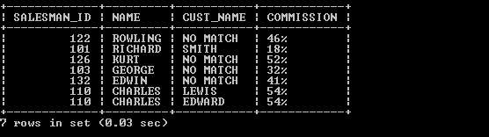

#### Create a view that finds the salesman who has the customer with the highest order of a day.

CREATE VIEW VW_ELITSALESMAN AS

SELECT B.ORD_DATE,A.SALESMAN_ID,A.NAME FROM SALESMAN A, ORDERS B WHERE A.SALESMAN_ID = B.SALESMAN_ID AND B.PURCHASE_AMT=(SELECT MAX(PURCHASE_AMT) FROM ORDERS C

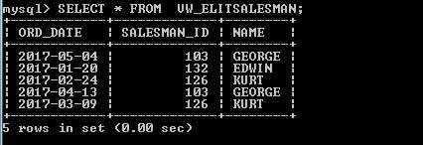WHERE C.ORD_DATE = B.ORD_DATE); SELECT * FROM VW_ELITSALESMAN

#### Demonstrate the DELETE operation by removing salesman with id 1000. All his orders must also be deleted.

Use ON DELETE CASCADE at the end of foreign key definitions while creating child table orders and then execute the following:

DELETE FROM SALESMAN WHERE SALESMAN_ID=101;

